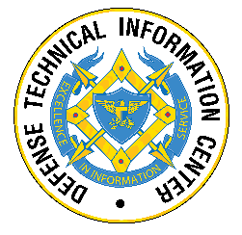

CSIAC TECHNICAL INQUIRY (TI) RESPONSE REPORT
Artificial Intelligence/Machine Learning Transition Timetable

Report Number:
CSIAC-BCO-2022-249
Completed September 2022

CSIAC is a Department of Defense Information Analysis Center
Main OFFICE
4695 Millennium Drive
Belcamp, MD 21017-1505
Office: 443-360-4600
REPORT PREPARED BY:
Ma Xiu
Office: BluePath Labs

Information contained in this report does not constitute endorsement by the U.S. Department of Defense or any nonfederal entity or technology sponsored by a nonfederal entity.
CSIAC is sponsored by the Defense Technical Information Center, with policy oversight provided by the Office of the Under Secretary of Defense for Research and Engineering. CSIAC is operated by the SURVICE Engineering Company.

REPORT DOCUMENTATION PAGE |  |  |  |  |  |  | Form Approved  OMB No. 0704-0188
Public reporting burden for this collection of information is estimated to average 1 hour per response, including the time for reviewing instructions, searching existing data sources, gathering, and maintaining the data needed, and completing and reviewing this collection of information. Send comments regarding this burden estimate or any other aspect of this collection of information, including suggestions for reducing this burden to Department of Defense, Washington Headquarters Services, Directorate for Information Operations and Reports (0704-0188), 1215 Jefferson Davis Highway, Suite 1204, Arlington, VA 22202-4302. Respondents should be aware that notwithstanding any other provision of law, no person shall be subject to any penalty for failing to comply with a collection of information if it does not display a currently valid OMB control number. PLEASE DO NOT RETURN YOUR FORM TO THE ABOVE ADDRESS.
1. REPORT DATE (DD-MM-YYYY) |  | 2. REPORT TYPE  Technical Research Report |  |  |  |  | 3. DATES COVERED (From – To)
4. TITLE AND SUBTITLE |  |  |  |  |  |  | 5a. CONTRACT NUMBER  FA8075-21-D-0001
Artificial Intelligence/Machine Learning Transition Timetable |  |  |  |  |  |  | 5b. GRANT NUMBER
 |  |  |  |  |  |  | 5c. PROGRAM ELEMENT NUMBER
6. AUTHOR(S) |  |  |  |  |  |  | 5d. PROJECT NUMBER
Ma Xiu |  |  |  |  |  |  | 5e. TASK NUMBER
 |  |  |  |  |  |  | 5f. WORK UNIT NUMBER
7. PERFORMING ORGANIZATION NAME(S) AND ADDRESS(ES)  AND ADDRESS(ES) |  |  |  |  |  |  | 8. PERFORMING ORGANIZATION REPORT  NUMBER
Cybersecurity & Information Systems Information Analysis Center (CSIAC)
Blue Path Labs
2101 L St NW, Suite 800
Washington, DC 20037

9. SPONSORING/MONITORING AGENCY NAME(S) AND ADDRESS(ES) |  |  |  |  |  |  | 10. SPONSOR/MONITOR’S ACRONYM(S)
Defense Technical Information Center (DTIC)
8725 John J. Kingman Road |  |  |  |  |  |  | 11. SPONSOR/MONITOR’S REPORT
Fort Belvoir, VA 22060-6218 |  |  |  |  |  |  | NUMBER(S)
 |  |  |  |  |  |  | CSIAC-BCO-2022-249
12. DISTRIBUTION/AVAILABILITY STATEMENT

DISTRIBUTION A. Approved for public release: distribution unlimited.

13. SUPPLEMENTARY NOTES

The Cybersecurity and Information Systems Information Analysis Center (CSIAC) was asked how fast the People’s Republic of China (PRC) can transition artificial intelligence (AI)/machine-learning (ML) technologies from the lab to the field. CSIAC subject matter experts from BluePath Labs researched online, open-source, Chinese and English documents on the topic. They found that the speed of transition depended on sector and technology. Per one case study into high-temperature materials used in hypersonic flight vehicles, the transition from research lab to product prototyping was ~11 years. Overall, the PRC has had a low rate of success transitioning new technologies from lab to marketplace, with fewer than 10% of government-funded research outcomes successfully commercialized, despite high levels of investment from their government. The PRC’s military has traditionally relied on state-owned defense conglomerates for its equipment and technology. However, in recent years, they developed several vehicles to leverage the private sector for defense technology and innovation.

15. SUBJECT TERMS
artificial intelligence (AI), machine-learning (ML), China, technology, transition, autonomous, innovation, military, research, defense, commercial

16. SECURITY CLASSIFICATION OF: U |  |  |  | 17. LIMITATION  OF ABSTRACT |  | 18. NUMBER OF PAGES |  | 19a. NAME OF RESPONSIBLE PERSON  Ted Welsh, CSIAC Director
a. REPORT  U | b. ABSTRACT  U |  | c. THIS PAGE  U | UU |  | 11 |  | 19b. TELEPHONE NUMBER (include area code)  443-360-4600
Standard Form 298 (Rev. 8-98)
Prescribed by ANSI Std. Z39.18

ABOUT DTIC AND CSIAC
The Defense Technical Information Center (DTIC) preserves, curates, and shares knowledge from the U.S. Department of Defense’s (DoD's) annual multibillion dollar investment in science and technology, multiplying the value and accelerating capability to the Warfighter. DTIC amplifies this investment by collecting information and enhancing the digital search, analysis, and collaboration tools that make information widely available to decision makers, researchers, engineers, and scientists across the Department.
DTIC sponsors the DoD Information Analysis Centers (IACs), which provide critical, flexible, and cutting-edge research and analysis to produce relevant and reusable scientific and technical information for acquisition program managers, DoD laboratories, Program Executive Offices, and Combatant Commands. The IACs are staffed by, or have access to, hundreds of scientists, engineers, and information specialists who provide research and analysis to customers with diverse, complex, and challenging requirements.
The Cybersecurity & Information Systems Information Analysis Center (CSIAC) is a DoD IAC sponsored by DTIC to provide expertise in four technical focus areas: cybersecurity; knowledge management & information sharing; modeling & simulation; and software data & analysis. CSIAC is operated by SURVICE Engineering Company under contract FA8075-21-D-0001.
A chief service of the DoD IACs is free technical inquiry (TI) research, limited to 4 research hours per inquiry. This TI response report summarizes the research findings of one such inquiry jointly conducted by CSIAC.

ABSTRACT
The Cybersecurity and Information Systems Information Analysis Center (CSIAC) was asked how fast the People’s Republic of China (PRC) can transition artificial intelligence (AI)/machine-learning (ML) technologies from the lab to the field. CSIAC subject matter experts from BluePath Labs researched online, open-source, Chinese and English documents on the topic. They found that the speed of transition depended on sector and technology. Per one case study into high-temperature materials used in hypersonic flight vehicles, the transition from research lab to product prototyping was ~11 years. Overall, the PRC has had a low rate of success transitioning new technologies from lab to marketplace, with fewer than 10% of government-funded research outcomes successfully commercialized, despite high levels of investment from their government. The PRC’s military has traditionally relied on state-owned defense conglomerates for its technology. However, in recent years, they developed several vehicles to leverage the private sector for defense technology and innovation.

Contents
ABOUT DTIC AND CSIAC i
ABSTRACT ii
List of Figures iii
1.0 TI Request 1
1.1 Inquiry 1
1.2 Description 1
2.0 TI Response 1
REFERENCES 4
BIOGRAPHY 6

List of Figures
Figure 1: Comparison From Deloitte White Paper (Source: Deloitte [4]). 2

1.0 TI Request

1.1 Inquiry
How fast do artificial intelligence (AI)/machine-learning (ML) technologies transition from paper to fielded capability for the People’s Republic of China (PRC)?

1.2 Description
Cybersecurity and Information Systems Information Analysis Center (CSIAC) subject matter experts from BluePath Labs (BPL) attempted to answer how fast the PRC can transition AI/ML technologies from the lab to the field. Although information was difficult to obtain using open sources, they found that the speed of transition depended on sector and technology.

2.0 TI Response
According to a news article from June 2021 [1], the general message coming out of the 2020 China AI Industry Annual Conference (hosted by the Chinese Association of Artificial Intelligence) is that mature application of AI technology has so far been limited to speech recognition only. Other AI technologies, such as ML, computer vision, natural language processing, knowledge graphs, and intelligence will take “several years” to reach maturity, and autonomous vehicles are unlikely to appear in the next 10 years.
In an April 2020 report discussing AI weapons in China’s military innovation [2], Elsa B. Kania wrote the following:
“Based on publicly available information, the PLA’s trajectory in the development and potential employment of AI/ML-enabled and autonomous weapons systems remains uncertain. The maturity of these capabilities — as well as if, when, and to what extent weapons systems with greater levels of autonomy have been fielded — cannot be assessed with high confidence at this point.”
An October 2021 report by the Center for Security and Emerging Technology (CSET) noted that the People’s Liberation Army (PLA) is purchasing AI systems for “all manner of applications, including autonomous vehicles, intelligence analysis, decision support, electronic warfare and cyber operations” [3].
Deloitte released a report examining AI’s commercial applications in China [4]. The report included a comparison of key AI industry indicators between the United States and China (see Figure 1).

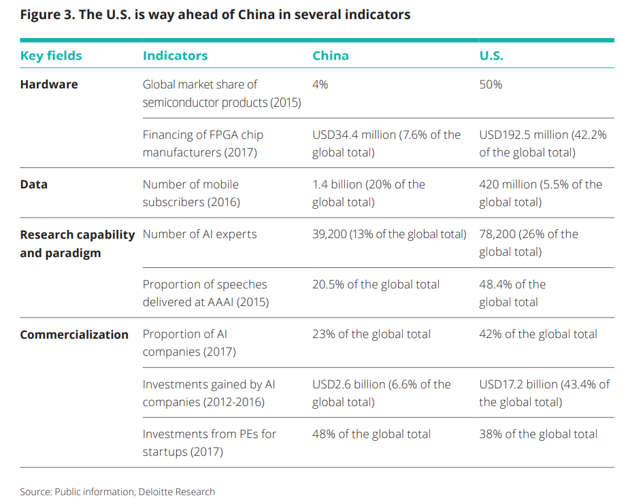
Figure 1: Comparison From Deloitte White Paper (Source: Deloitte [4]).
The speed of tech transition is sector and technology dependent. According to a speech by Chinese Science and Technology then-Deputy Minister Wang Zhigang in 2016, China has yet to develop a set of standardized indicators to track and quantify technology transfer activities [5].

A case study conducted by BPL into the research and development (R&D) process of high-temperature materials used on Chinese hypersonic flight vehicles and missiles suggested that the process of transitioning technologies from the research lab to product prototyping took about 11 years [6].

In general, Chinese analysts have noted that the rate of successful transitions of technologies from the research lab to the marketplace remains low across the board. According to Deputy Director of the Development Research Center of the PRC State Council Wang Yiming, less than 10% of government-funded scientific research outcomes have been successfully commercialized, suggesting a failure in policies designed to enhance the synergy between the research performers and the innovation system at large [7]. The low conversion rates indicated a low rate of return on investment for the Chinese central and local governments, which together spent 1.1 trillion RMB (Chinese currency which is approx. 159.9 billion dollars) supporting broad scientific and technical information development in 2019 and 454 billion RMB (approx. 66 billion dollars) on research and development [8, 9].

The Chinese military has traditionally relied on state-owned defense corporations for equipment and technology needs. In recent years, however, the PLA has created multiple programs and channels to leverage private sector technologies more rapidly in response to defense technology innovation needs. Most of the programs are run by the Central Military Commission’s Science and Technology Committee and the Equipment Development Department. Some examples include the following:
- A “defense science and technology innovation rapid response task force” (sometimes characterized as China’s DIUx), which operates out of offices in Shenzhen, Dalian, and Chongqing [10]. In the first quarter of 2020 alone, the Shenzhen office released six sets of requests for proposals, seeking technologies ranging from unmanned aerial vehicle fast obstacle avoidance technology and software-defined multifunction sonar to preparation technology of ceramic coatings [11, 12].
- “Operation Acumen,” the Central Military Commission's first attempt to leverage private sector innovation capabilities to rapidly produce a new application in support of PLA equipment development needs [13].
- “National Defense Science and Technology 173 Program,” which seeks commercial, off-the-shelf solutions [14].

REFERENCES
[1] Chinanews.com. “How Long Will It Take to Move From the Lab to Large-Scale Commercial AI?” https://www.chinanews.com.cn/cj/2021/06-03/9491501.shtml, 3 June 2021.
[2] Kania, E. B. “AI Weapons in China's Military Innovation.” https://www.brookings.edu/ research/ai-weapons-in-chinas-military-innovation/, April 2020.
[3] Fedasiuk, R., J. Melot, and B. Murphy. “Harnessed Lightning: How the Chinese Military Is Adopting Artificial Intelligence.” Center for Security and Emerging Technology (CSET), Harnessed Lightning - Center for Security and Emerging Technology (georgetown.edu), October 2021.
[4] Deloitte. “Intelligence Driven by Innovation.“ Deloitte released China AI white paper, "Intelligence Driven by Innovation" - Deloitte released China AI Industry Whitepaper | Deloitte China | Innovation, accessed 2021.
[5] Zhigang, W. "Promote the Transformation of Scientific and Technological Achievements." http://www.npc.gov.cn/npc/c541/201612/0834c1d81f4548b4a299f19eb884bd1b.shtml, 26 December 2016.
[6] Stone, A. "China’s Model of Science: Rationale, Players, Issues." China Aerospace Studies Institute, https://www.airuniversity.af.edu/Portals/10/CASI/documents/Research/ Infrastructure/2022-02-07%20Model%20of%20Science.pdf, 7 February 2022.
[7] Yiming, W. “Increase the Conversion Rate of Technological Achievements Supported by Financial Funds.” Beijing Daily, http://www.cssn.cn/zx/201904/t20190408_4860831.shtml, 8 April 2019.
[8] National Bureau of Statistics. “Statistical Communiqué on National Science and Technology Expenditures in 2019.” http://www.stats.gov.cn/tjsj/zxfb/202008/t20200827_1786198.html, 27 August 2020.
[9] Fenzi, Z. “Report on China’s R&D Expenditure (2020).” http://m.zhishifenzi.com/news/ multiple/11239.html, 1 May 2021.
[10] Defense Science & Technology Innovation Rapid Response Force. “Publish the First Batch of Guidelines for Technology Fund Projects in 2021.” https://mp.weixin.qq.com/s/ wI8m2dkHrAxthitZOHJTJg, 23 February 2021.
[11] Military-Civilian Integration Public Service Platform Operation Management Office. “Notice on the Release of the Fourth Batch of Requirements in 2020 by the National Defense Science and Technology Innovation Rapid Response Team (Shenzhen).” https://www.hnjmrh.gov.cn/ newweb/newinfo/detail/3394/, 24 February 2020.
[12] Office of the Defense Science & Technology Innovation Rapid Response Force. “Notice on the Release of the Sixth Batch of Requirements in 2020 by the National Defense Science and Technology Innovation Rapid Response Team (Shenzhen).” https://www.hnjmrh.gov.cn/ newweb/newinfo/detail/3542/, 26 March 2020.
[13] Blue Ocean Evergreen Think Tank. “Announcement on the Collection of the First Batch of Innovative Achievements in 2021 for the ‘Smart Eye Action" of the Equipment Development Department of the Military Commission | With an introduction to the ‘Smart Eye Action’.” https://www.163.com/dy/article/G2DAMRJA0511DV4H.html, 9 February 2021.
[14] Defense Science & Technology Innovation Rapid Response Force. “Publish the First Batch of Guidelines for Technology Fund Projects in 2021.” https://mp.weixin.qq.com/s/wI8m2dkHrAxthitZOHJTJg , 23 February 2021.

BIOGRAPHY
Ma Xiu (a pseudonym) is a senior analyst at BluePath Labs (BPL), where he conducts Chinese-language open-source research into the People’s Liberation Army. His most recent reports include a comprehensive order of battle for the PLA Rocket Force and an analysis of the PRC’s defense lab system, both written for the China Aerospace Studies Institute. Prior to joining BPL, he lived in Beijing and Xinjiang, where he studied both Mandarin Chinese and Uyghur and worked as a translator. He has a master’s degree in international affairs from the Fletcher School of Law and Diplomacy at Tufts University.

